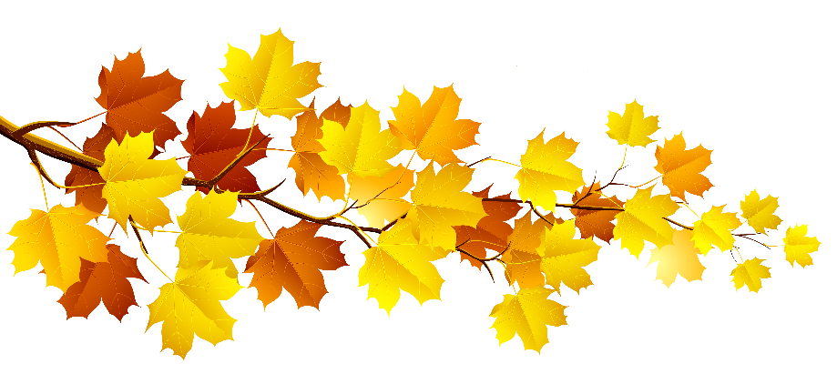
Autumn Leaves Are Falling.
“Leave” Them on Your Lawn for a Healthy Yard & Clean Water!

Autumn leaves are starting to fall and now is a good time to consider alternatives to dumping them in the street for pick-up. Even though your community may offer this service, you might want to consider the option of recycling those leaves on your own property, which is after all, Mother Nature’s method of recycling. (Little elves are not out in the forests raking and bagging leaves.) Recycling leaves on your lawn will also keep them out of the storm drains and away from our surface waters where they would only add nutrients and encourage algae blooms.
It takes a little bit of time, but eventually, all of the leaves are transformed by worms, bacteria, and other soil organisms into rich humus, which will continue to feed trees, shrubs, and other plants. Your yard will benefit from this natural process for years to come.
Trees on your property draw nutrients and minerals from the soil, converting them into new leaves and branches. When you rake up those leaves, you interfere with the natural cycle by which nutrients are returned to the soil. After a number of years, the soil will lose its fertility and ultimately affect the health of all the plants that you are trying to grow. Spreading costly fertilizers on your lawn may restore some nutrients, but not all of the vital minerals and organic matter needed for healthy, vigorous plants. On the other hand, leaves contain all of the nutrients and micronutrients that your lawn needs. So you need to get your leaves back into your soil somehow, and the best way to do that is to use your lawnmower.
For many years now, almost all new lawnmowers have been marketed as mulching mowers. After decades of bagging clippings, a majority of homeowners have learned that it is best to “grasscycle” their lawn clippings when they mow. Clippings left in place decompose quickly and provide nutrients to keep the lawn healthy. “Grasscycling” clippings also keeps them out of the storm drains and surface waters, where they can also become a culprit along with the leaves, in depositing excess nutrients during rainstorm runoff. Your lawnmower can do double-duty as a leaf mulcher as well. Mower blades can easily shred whole leaves into small pieces, approximately one-tenth of their original size. Your huge bounty of leaves will disappear into a thin layer of small particles which are easily digested by worms, bacteria, and other tiny soil organisms. In fact, a healthy earthworm population is capable of dragging a one-inch layer of organic matter down into the underground burrows in just a few months. Unseen by human eyes, they are diligently loosening and enriching your soil, and feeding the roots of your lawn for free.
Begin the work of leaf-mulching by setting the mower to a normal three-inch height. Remove bagging attachments and block off the chute on a rear-discharge machine. Run your mower over the lawn while walking slowly, giving the mower blades plenty of time to shred up the leaves. Please note that mower-mulching works best when leaves are relatively dry and are no more than one inch deep, so try and start the process when leaves are just starting to fall. If your mower has a side discharge chute, you will probably want to begin on the outside perimeter of your lawn, blowing your chopped leaves onto unmowed areas, and continue mowing inward. This will keep the leaf particles on the lawn and even allow your mower to mow over them a few more times. If your first pass over the lawn has left a significant quantity of whole leaves, go back over the leaves while mowing at a right angle to the first cut. Leaves take more work than grass, especially if they are somewhat damp.
Shredded leaves may be used for other healthy additions to your landscape. You can apply the leaves as mulch two to four inches thick under your trees and shrubs, being careful to keep the shredded material away from the tree trunk and root crown. The leaves can also be applied to planting beds like perennial beds and herb gardens. A two to three inch mulch layer will help maintain a uniform soil temperature all winter and protect tender root systems. The mulch blanket will also prevent frost upheaval caused by frequent thawing and refreezing, which is especially damaging to bulbs, tuberous flowers, and some less hardy perennials. The leaf mulch will also feed your plants by recycling nutrients, conserving soil moisture during dry spells, and prevent the emergence of weeds. Avoid applying mulch until after the first hard freeze.
You can also add your shredded leaves to a compost pile or bin. The smaller leaf particles decompose in about 75 per-cent of the time required by whole leaves and you will be able to add a large quantity of whole leaves which will give you a lot of mulch to use if you have a property with many mature trees. If you are still cutting some grass blades as you run over the leaves, you are probably creating the perfect combination of materials to establish an effective, fast-working compost pile which will reward you with nutrient-rich compost ready for use in the spring.
Mulching leaves into your lawn is just the first step toward a naturally healthy lawn. You can aerate your lawn with a core-aerating machine available for rent, or you can hire a lawn care service for liquid aeration. Either way, aerating works well, especially on compacted soils, making spaces for air and water to infiltrate, and making room for organic matter to filter deeper into subsoils and root zones.
You should also test your soil to see what nutrients it needs, if any, and if your soil needs to be limed to adjust the Ph. Since autumn is the best time to fertilize, you can use your soil-test results to determine fertilizer needs. You should use organic, slow-release fertilizer, preferably animal manure, to feed the soil and your lawn’s roots all winter long.
If you choose to recycle your leaves along with grass clippings, you will protect your landscape from the ravages of winter and you can look forward to spring by creating a healthy environment for spring planting. You will also have the satisfaction of knowing that your have had a positive impact, now and in the future, on the water quality of our streams and lakes in Northeast Ohio.

References:
Montgomery County, Maryland, Department of Environmental Protection
Summit Soil & Water Conservation District

