Wet Basements, Yuck!
When it rains, and the rainwater has no place to go because of all the roofs, sidewalks, streets, parking lots and other impervious surfaces resulting from development, the ground becomes saturated. Water flows underground as well as above ground so if your basement happens to be in the path of that water flow, and is not properly waterproofed, water will seep into it.
Our Summit County Office of Consumer Affairs has kindly provided a timely article by Kathy Seminatore that contains very credible information which will help you if you are having wet basement problems, and here it is:
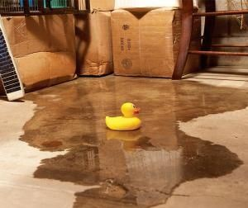

Wet Basements, YUCK! Basement waterproofing is very expensive and it doesn’t always work. The average cost is $15,000.00 and up. The Office of Cunsumer Affairs has received several complaints against waterproofing companies in Summit County after shoddy, unprofessional work was done and not fixed.
If your foundation needs to be repaired, consult with a foundation contractor, not just a company who claims that they are basement experts. Beware of a company that only digs 3-4 feet down along your foundation, yet they charge the same if they had to dig to the bottom!
There are at least a dozen basement waterproofing companies in the Summit County area, but they are not all “foundation experts.” Choosing a foundation contractor versus a waterproofing company can mean the difference between worsening your problem and correcting it. A foundation contractor can also determine if the problem is exterior or interior and what method to use to fix it.
Exterior: Excavation to the bottom of the foundation, installing proper drainage and treating walls to prevent water from entering. This is waterproofing.
Interior: Installation of a sump pump. A sump pump lets the water in under the basement floor and then pumps it out. This is not so much waterproofing as it is water control. A foundation expert will tell you what failed and let the water in. Foundation experts will probably suggest exterior waterproofing. However, a less costly and effective alternative in at least some instances would be the installation of a sump pump.
Beware of companies who offer some outside work such as digging a shallow draining system or trenches. This outside work does very little to help or prevent water problems and it costs more because they will also do inside work. Any outside excavation is only effective if you dig to the bottom of your foundation.
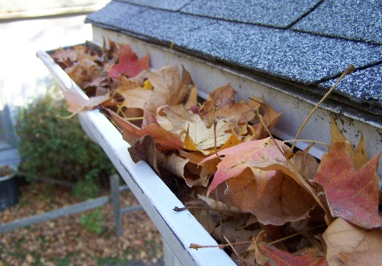
Beware of companies who offer Water-Proofing Panels. This solution is temporary. These panels are expensive and judged often to be ineffective. This method uses a plastic wall panel that is installed on the basement wall and is supposed to trap the water. If the water is trapped by this panel, the water already got through the foundation. This is not doing anything to prevent water damage. Over time, the water that is going through the foundation will eventually cause more damage which will lead to a more expensive repair. These wall panels are only another money-making tactic for the waterproofing company.
- Don’t fall for the sales pitch of a Discount if you sign the contract today!
- Do Not Make a Same Day Decision.
- If you feel pressure or feel they are scaring you into buying their product, show them to the door.
- Don’t let them make you feel bad if you cut them short and tell them you have heard enough and will let them know when you make your decision.
- Do Not Fall for the pitch that your house will fill in if you don’t fix it.
- Get another opinion. Research the company’s reviews. Ask for references and check them. Check with Consumer Affairs, The Attorney General’s Office and your local Better Business Bureau for ratings and prior complaints.

Other Methods to Help Prevent Wet Basements
Keep Your Gutters Clean

When clogged gutters overflow, rain water can pool around your foundation. Over time, this can damage your foundation. Remove leaves, dirt, and debris left over from winter. Installing leaf guards will help prevent clogs and downspout extenders will help direct water away from your foundation.
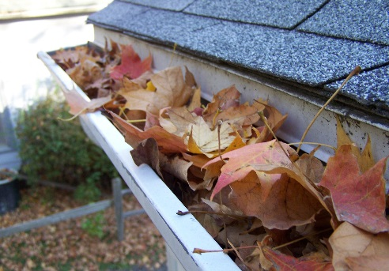

Grade your yard away from your house
Grading the soil away from the house at least ¼ inch per foot so water will drain
away from your foundation. Make sure the soil is higher at the foundation and
graded down toward your yard.

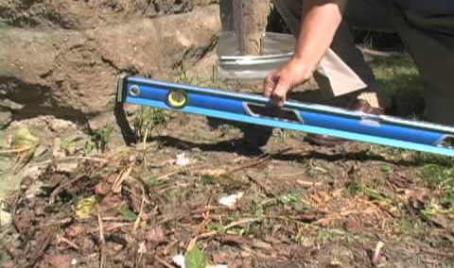

Planting and Removing Trees around your house

Shade trees with aggressive roots, like weeping willows and silver maples should
be removed if they are closer than 20 feet from your house. If they are close to
your house the roots will expand into your foundation and cause damage. Plant
them at least 20 feet from your house to protect your foundation. Smaller
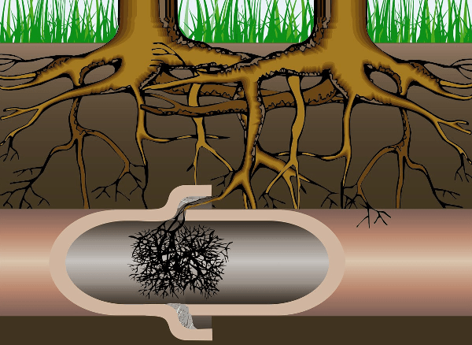
species, like white fir, require only 10 to 15 feet of clearance.

For more information on this or other consumer issues, you may contact the Summit County Office of Consumer Affairs at 330-643-2879, or go to https://consumeraffairs.summitoh.net/.

